Press kit huggable robot Probo
Probo has a soft appearance and looks like a green elephant-like huggable, but is much more than that. The inside of Probo is full of high tech: 20 precision motors, sensors, electronics and a touch screen. The robot is able to show facial expressions and can sense its environment. Probo is one of the first robotic platforms with a special focus on interaction studies of emotional communication between robot and child. The robot will be used as research platform in a multidisciplinary team to enlighten the children’s stay in the hospital. On April 21st the first prototype was presented at the Vrije Universiteit Brussel in the presence of Brussels ministers Guy Vanhengel en Benoît Cerexhe.

Why Probo?
The new generation of robots will collaborate with humans in many different aspects of the daily life: from domestic tasks to elderly, health and child care. Communication is hereby essential. More than 60% of our communication is non-verbal, mostly by facial expressions. Therefore it is very important to develop robots that are able to reproduce and interpret these expressions. Crucial for those new technologies is that the human plays a central role in the communication, this infers that the robot should adapt its communication means to the one of humans and not the other way around as is the case now with computers and mobile phones. Probo will serve as research platform for cognitive human-robot interaction studies. Probo has a high huggable appearance because specifically children are targeted. Probo will for example assist in providing information and moral support to hospitalized children.
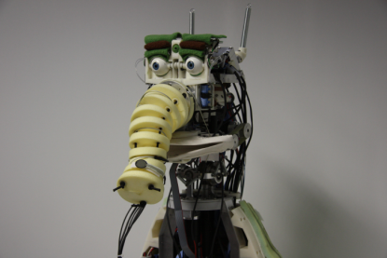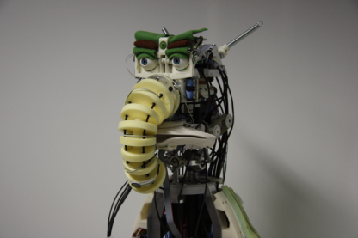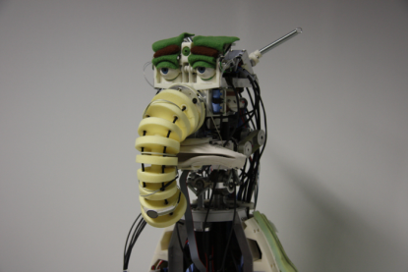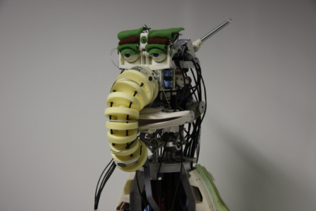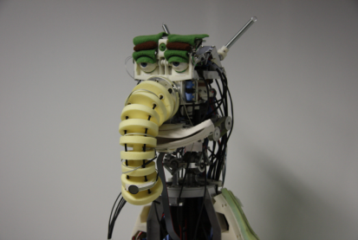

Who is Probo?
Probo is an imaginary animal type with an own identity, including a name and a history. The name Probo is derived from the word proboscidea. Proboscidea is an order that now contains only one family of living animals, the elephants. During the period of the last ice age there were more, now extinct species, including the mammoths and mastodons. In the name Probo we can also see the word "ROBO" which emphasizes the robotic nature of Probo.
The mechanics of Probo are covered by protecting plastic shells, a layer foam and a soft fur to make the robot soft and huggable. The colour of the robot is green, this colour evokes mainly positive emotions such as relaxation and comfort. The recognition of facial expressions using the virtual model of Probo was tested in different user-studies. The results showed that the recognition of the emotional states of Probo are good with an overall identification rate of 88 %, especially by children.
The choice to give Probo the looks of an imaginary animal is done deliberately. Now no special expectations are created which are unavoidable when the character of a cat or dog was chosen. This offers the possibility to add special features like the touch screen in the belly and to develop a special language for Probo.

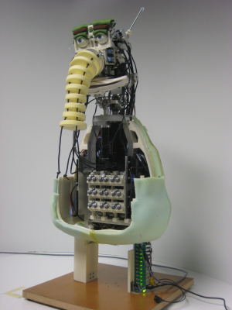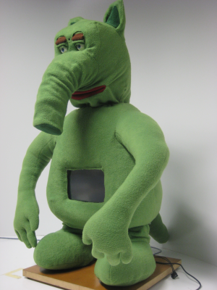

What is inside Probo?
The robot has 20 high precision motors in its head. They are used to actuate the ears, eyebrows, eyelids, eyes, trunk, mouth and neck. To build safety aspects intrinsically in the robots hardware all the motors have a spring in series (series elastic actuation, SEA) so in case of a collision the robot will be elastic and safe while providing a soft touch. The joint can be easily moved when an external force acts on it. So for example the trunk can be taken and moved around unrestricted.
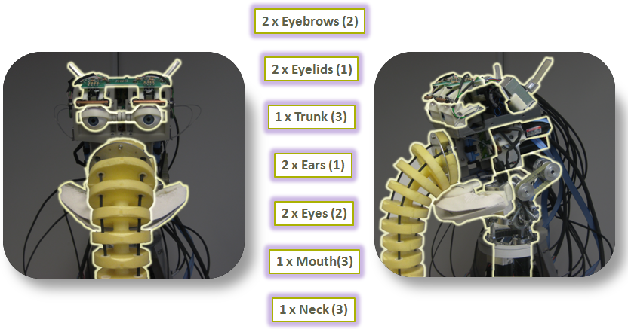

How is Probo controlled?
Probo is controlled by a dedicated software program, the Robotic User Interface (RUI). At the moment an operator commands the robot. Gradually more and more artificial intelligence components will be implemented in the robot to increase the autonomy of the robot and to reduce the role of the operator. In order to act autonomously, the robot has to be able to sense its environment. Therefore the robot is equipped with different sensors like a digital camera in the head, different microphones and touch sensors under the fur.
To realize a translation from emotions into facial expressions, emotions are parameterized. In our model two dimensions are used: valence and arousal to construct an emotion space. Each emotion is represented as a vector with the origin of the coordinate system as initial point and the corresponding arousal-valence values as the terminal point. In the center is the neutral emotion. The direction of each vector defines the specific emotion whereas the magnitude defines the intensity of the emotion. Each basic emotion correspondents with a certain position of the motors to express the facial expressions as studied in the user test. Using this method, smooth and natural transitions are obtained between the different emotions as surprise, repulsive, angry, unhappy, bored, sleepy, relaxed and happy.
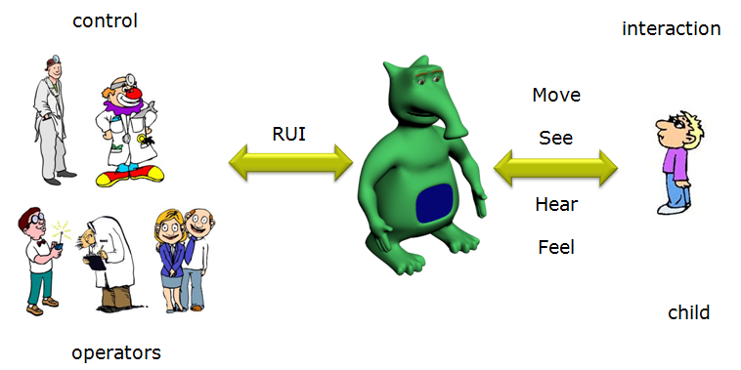

What will Probo do?
Probo will play a role in research in three different disciplines. Engineering research teams will increase the autonomy of the robot using vision, speech and artificial intelligence. Those fields are extensively studied and using Probo they will be able to test and validate their research.
In collaboration with the medical area the possibilities in Robot Assisted Therapy (RAT) will be explored. This kind of therapy is already successfully tested with elderly and autistic children. A specific focus of Probo is long termed hospitalized children. For example Probo will prepare and assist children for medical routines, therapy or operations. As well, the robot can be used for edutainment purposes and can serve as a videoconferencing platform.
Together with sociology and psychology the human-robot interaction will be studied and the possibilities of emotional communication will be explored.
For educational purposes, Probo serves as a platform for small projects, which are outsourced to secondary schools, high schools or universities. In those projects the students work on a specific element of the project, knowing that their work is part of a bigger concept proves very motivating. In this way the project motivates students and stimulates new technological innovation.

What are the future plans of Probo?
The prototype will be further improved to a market-ready product. Besides the head, also the body and arms will be actuated so besides emotions also gestures and poses can be shown. This will ensure that Probo contains all the capabilities to remain a unique platform for human-robot interaction studies. Different copies will be built and made available as research platform for research institutes and hospitals. A multidisciplinary team will create technologies to implement on the robot. Like this the autonomy and intelligence can be gradually increased. There are also plans to create a spin-off to commercialize Probo and derived products, possible markets are research institutes, amusement parks and museums.

What is the ProboGotchi-game?
The ProboGotchi-game is a derived product which combines in a creative manner the different modules developed for Probo. ProboGotchi is a 3D game with the huggable robot as main actor. Goal is to make Probo happy and take care of him. This is done by feeding, washing and hugging the robot. When Probo is sick or not well taken care of, microbes or fleas appears that need to be destroyed. Probo reacts to the different actions of the user. Unique is the way how the game is played. A stuffed version of Probo is equipped with touch sensors and acts as an innovative game controller that detects how the robot is hugged, scratched or hurt. This game gives the possibilities to explore haptic interaction and the concepts how needs control the emotional state of Probo.
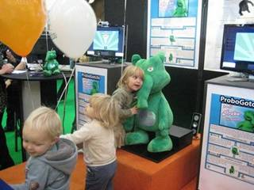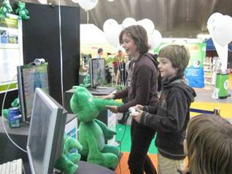

Who has built the robot?
The initial idea to build a huggable robot for hospitalized children comes from Ivan Hermans. Ivan Hermans is founder of the Anty Foundation. The Anty Foundation (www.anty.org) is a non-profit organization whose purpose is to improve the life circumstances of vulnerable children. Katia della Faille is goodwill ambassador of the Anty Foundation.
The promoters are Dirk Lefeber and Bram Vanderborght.
Dirk Lefeber is head of the robotics lab at the VUB. His research group is interested in walking robots, compliant actuation, safe human-robot interaction, rehabilitation robotics and of course cognitive human-robot interaction with the robot Probo.
Bram Vanderborght developed the walking robot Lucy during his PhD. In Japan he programmed on the humanoid robot HRP-2. He is also connected to the Italian Institute of Technology where he collaborates on the child robot iCub.
The construction and programming was performed by Jelle Saldien, Kristof Goris and Jeroen Vandenbrande.
Jelle Saldien is industrial engineer with an additional degree in product development. His master’s thesis was a pre-study on Probo. The focus of his research is the design and the construction of the robot Probo and the control software with the implementation of emotions and facial expressions. Jelle will graduate at the end of the year on this subject.
Kristof Goris is electro-mechanical engineer and the focus of his PhD is the design and the construction of the hardware of robot Probo and the implementation of inherent safe and compliant actuation. Kristof will graduate at the end of the year on this subject.
Jeroen Vandenbrande is industrial engineer and technician of the project.
Probo is developed with the support of Brussels ministers Guy Vanhengel (responsible for informatics) and Benoît Cerexhe (responsible for scientific research) through the ISRIB (Institute for the encouragement of Scientific Research and Innovation of Brussels) and CIBG (Brussels Regional Informatics Centre).

When the general public is able to see Probo for the first time?
Probo will be shown for the first time to the general public during the robot contest RoboCup Junior in the science museum Technopolis on May 16th. Also the ProboGotchi-game can be played during that day. More info : www.robocupjunior.be

Contact information
Jelle Saldien (researcher): 0485-27 19 81
Prof. dr. ir. Dirk Lefeber (promotor): 0497-91 42 09
Press office Vrije Universiteit Brussel: Karolien Merchiers: 02-629 21 37 or 0473-96 41 37
Nadya De Beule, spokesperson minister Vanhengel: 0497-59 99 73
Béatrice Van Schendel, spokesperson minister Cerexhe: 0499-58 88 51

High resolution pictures and videos can be downloaded from:
http://probo.vub.ac.be/press/
Please use credit: “Probo – Vrije Universiteit Brussel”

